EXPERIMENT 7B
DATA VISUALIZATION USING TABLEAU
Aim:
To connect, analyze, visualize, and create an interactive FIFA World Cup 2026 player performance dashboard using Tableau for effective sports data analytics.
Algorithm:
Algorithm: FIFA Player Performance Data Visualization using Tableau
Step 1: Data Loading
- Connect the FIFA World Cup 2026 Player Performance CSV dataset to Tableau.
- Verify the important fields: player_name, team, goals, player_rating, and performance_score.
- Check that goals, ratings, and performance scores are recognized as numerical measures.
Step 2: Team-wise Goal Bar Chart
- Create a worksheet for team-wise goal analysis.
- Place team on Columns or Rows.
- Place goals on Rows or Columns.
- Select the Bar Chart visualization.
- Use SUM(goals) and enable data labels.
Output: Team-wise Total Goals
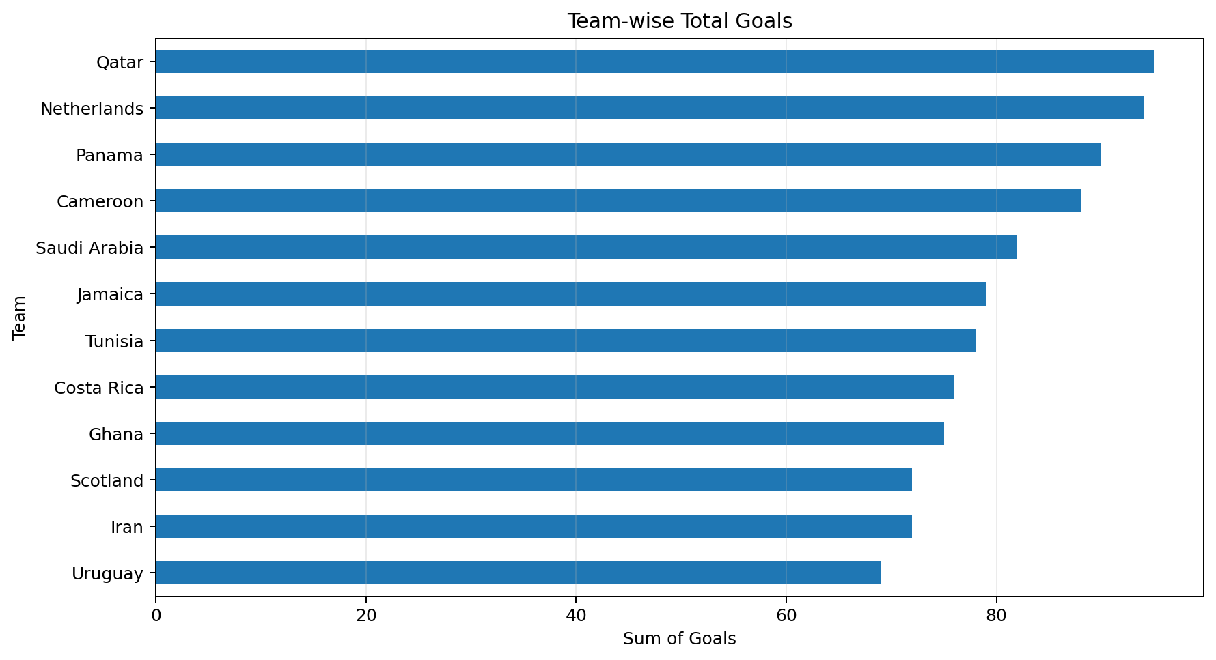
Step 3: Match Result Distribution Pie Chart
- Create a worksheet for match result distribution.
- Place match_result in the Color or Label area.
- Use COUNT(match_result) or COUNTD(match_id) when a match ID is available.
- Select the Pie Chart visualization.
- Display category names and percentages as labels.
Output: Match Result / Team Distribution
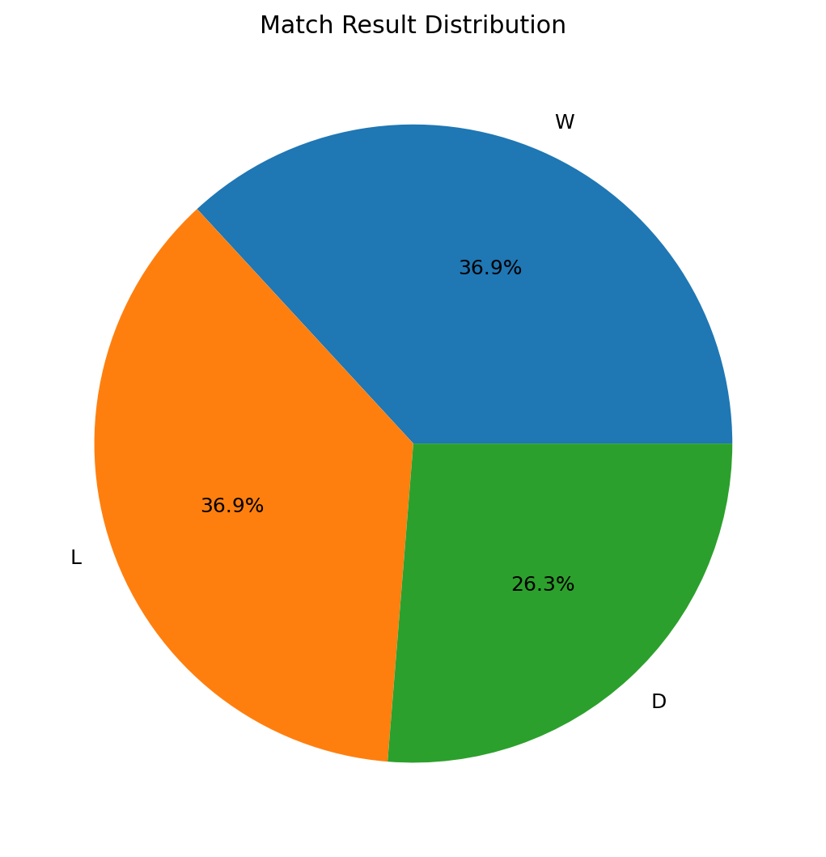
Step 4: Performance Trend Line Chart
- Place match_date on Columns.
- Place SUM(goals) on Rows.
- Select the Line Chart visualization.
- Use the chart to observe changes in performance or goals.
Output: Performance Trend
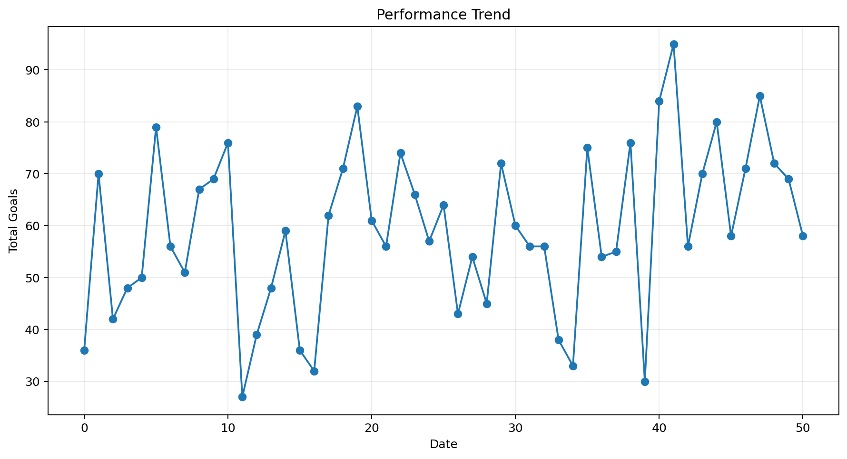
Step 5: Calculated Field
- Create a calculated field named Total Goals.
- Use the formula:
SUM([goals])
- Display the calculated total goals measure in a worksheet.
- Use AVG(player_rating) for average rating analysis when required.
Step 6: Team Filter
- Add team to the Filters shelf.
- Select any available team.
- Observe how the charts change according to the selected team.
Step 7: Minimum Performance Score Parameter
- Create a parameter named Minimum Performance Score.
- Set the parameter value to 70.
- Create a calculated field using the condition:
[performance_score] >= [Minimum Performance Score]
- Apply the calculated field as a filter to display players meeting the selected score.
Output: Minimum Performance Score Parameter
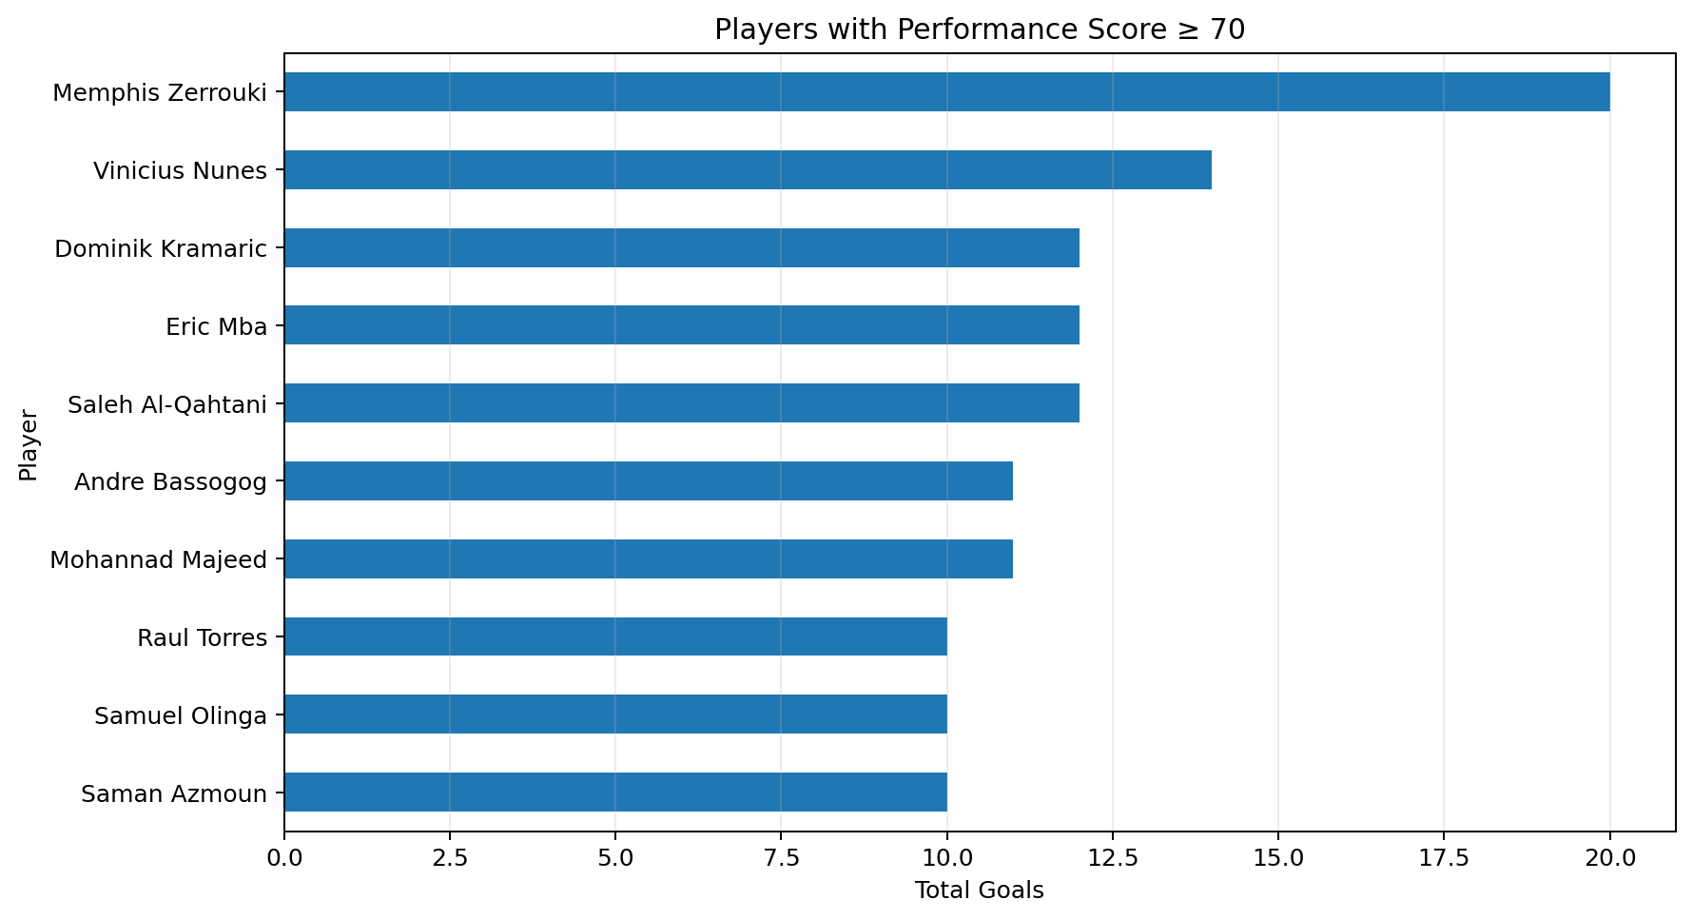
Step 8: Dashboard Creation
- Create a new Tableau Dashboard.
- Add the Team Goals Bar Chart, Distribution Pie Chart, Performance Trend Line Chart, and Minimum Score Chart.
- Add the Team filter and Minimum Performance Score parameter.
- Arrange the visualizations clearly and add suitable titles, labels, legends, and tooltips.
Step 9: Analysis
- Identify the teams with the highest total goals.
- Observe the distribution of match results or team records.
- Analyze performance changes over time or across players.
- Observe the effect of the Team filter and Minimum Performance Score parameter.
- Compare average player ratings among teams.
Output:
The output contains a team-wise goal bar chart, distribution pie chart, performance trend line chart, minimum performance score visualization, and average rating analysis based on the FIFA World Cup 2026 Player Performance dataset.
Result:
Thus, the FIFA World Cup 2026 Player Performance dataset was successfully prepared for Tableau visualization using bar charts, pie charts, line charts, calculated fields, filters, and parameters. The visualizations support the analysis of player and team performance.

